



Deep Learning
LAB MANUAL

Disclaimer: The content is curated from online/offline resources and used for educational purpose only
Forest Fire Detection Using Deep Learning
Objective:
The objective of this project is to develop a deep learning-based forest fire detection system using Convolutional Neural Networks (CNNs). The system will help in identifying fire incidents in images, enabling timely responses to mitigate wildfire risks.
Problem Statement
Design a deep learning-based system to detect forest fires using image classification techniques. The system should analyze images and classify them into two categories: 'fire' and 'nofire'. By leveraging Convolutional Neural Networks (CNNs), the model aims to provide accurate fire detection, assisting in early intervention and disaster prevention.
Equipment Required
- Python installed with Jupyter Notebook / VS Code / Google Colab
- TensorFlow and Keras - for deep learning model development and CNN-based image classification
- Matplotlib - for visualizing image samples and training performance
- A dataset of labeled images organized into 'fire' and 'nofire' folders
Prerequisites
- Basic knowledge of Python
- Understanding of TensorFlow and Keras
- Familiarity with model training and evaluation
Note: Use Kaggle Notebooks for this Lab
To use the kaggle notebook – Click on the dataset link - https://www.kaggle.com/datasets/elmadafri/the-wildfire-dataset
Once the link opens, on the right side, click on three dots, and select New Notebook.
Start typing the code below in the notebook
Procedure
Step 1: Import Required Libraries
import tensorflow as tf
import matplotlib.pyplot as plt
from tensorflow.keras.preprocessing.image import ImageDataGenerator
from tensorflow.keras.models import Sequential
from tensorflow.keras.layers import Conv2D, MaxPooling2D, Flatten, Dense, Dropout
from tensorflow.keras.optimizers import Adam

Step 2: Specify the dataset paths
These paths point to the training, validation, and testing folders available in the Kaggle dataset.
train_dir = "/kaggle/input/datasets/elmadafri/the-wildfire-dataset/the_wildfire_dataset_2n_version/train"

val_dir = "/kaggle/input/datasets/elmadafri/the-wildfire-dataset/the_wildfire_dataset_2n_version/val"

test_dir = "/kaggle/input/datasets/elmadafri/the-wildfire-dataset/the_wildfire_dataset_2n_version/test"

Step 3: Create the image data generators
Training images are augmented to improve generalization. Validation and test images are only normalized. The images are resized to 128 × 128 pixels.
img_size = (128, 128)
batch_size = 16
# Data augmentation for training
train_datagen = ImageDataGenerator(
rescale=1./255,
rotation_range=20,
zoom_range=0.2,
horizontal_flip=True
)
# Validation and test data are only normalized
test_datagen = ImageDataGenerator(
rescale=1./255
)
train_generator = train_datagen.flow_from_directory(
train_dir,
target_size=img_size,
batch_size=batch_size,
class_mode="binary"
)
validation_generator = test_datagen.flow_from_directory(
val_dir,
target_size=img_size,
batch_size=batch_size,
class_mode="binary"
)
test_generator = test_datagen.flow_from_directory(
test_dir,
target_size=img_size,
batch_size=batch_size,
class_mode="binary",
shuffle=False
)
print("Class Indices:", train_generator.class_indices)

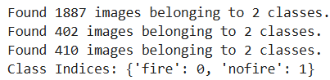
Step 4: Build the CNN Model
The CNN extracts features from images using convolutional layers and pooling layers. The fully connected layer performs classification, while the dropout layer reduces overfitting.
model = Sequential()
# Block 1
model.add(Conv2D(16, (3,3), activation="relu", input_shape=(128,128,3)))
model.add(MaxPooling2D((2,2)))
# Block 2
model.add(Conv2D(32, (3,3), activation="relu"))
model.add(MaxPooling2D((2,2)))
# Block 3
model.add(Conv2D(64, (3,3), activation="relu"))
model.add(MaxPooling2D((2,2)))
# Classification Layers
model.add(Flatten())
model.add(Dense(64, activation="relu"))
model.add(Dropout(0.5))
model.add(Dense(1, activation="sigmoid"))
model.summary()

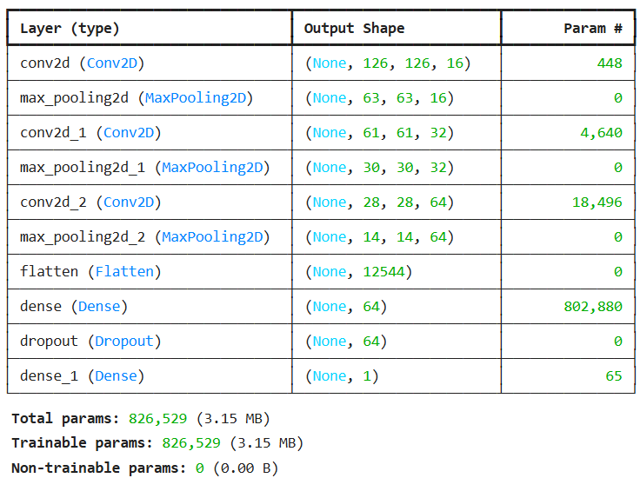
Step 5: Compile the Model
Adam is used for optimization. Binary Crossentropy is used because there are two classes. Accuracy is used to measure model performance.
model.compile(
optimizer=Adam(learning_rate=0.001),
loss="binary_crossentropy",
metrics=["accuracy"]
)

Step 6: Train the Model
The model learns from the training images and its performance is evaluated on the validation dataset after each epoch.
history = model.fit(
train_generator,
validation_data=validation_generator,
epochs=10
)

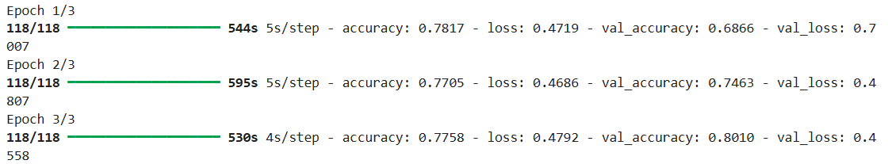
Step 7: Evaluate the Model
The trained model is evaluated on unseen test images to measure its final performance.
test_loss, test_accuracy = model.evaluate(test_generator)
print("Test Loss:", test_loss)
print("Test Accuracy:", test_accuracy)

Step 8: Plot Accuracy
This graph compares the training accuracy and validation accuracy across all epochs.
plt.figure(figsize=(8,5))
plt.plot(history.history["accuracy"], label="Training Accuracy")
plt.plot(history.history["val_accuracy"], label="Validation Accuracy")
plt.title("Training vs Validation Accuracy")
plt.xlabel("Epoch")
plt.ylabel("Accuracy")
plt.legend()
plt.show()
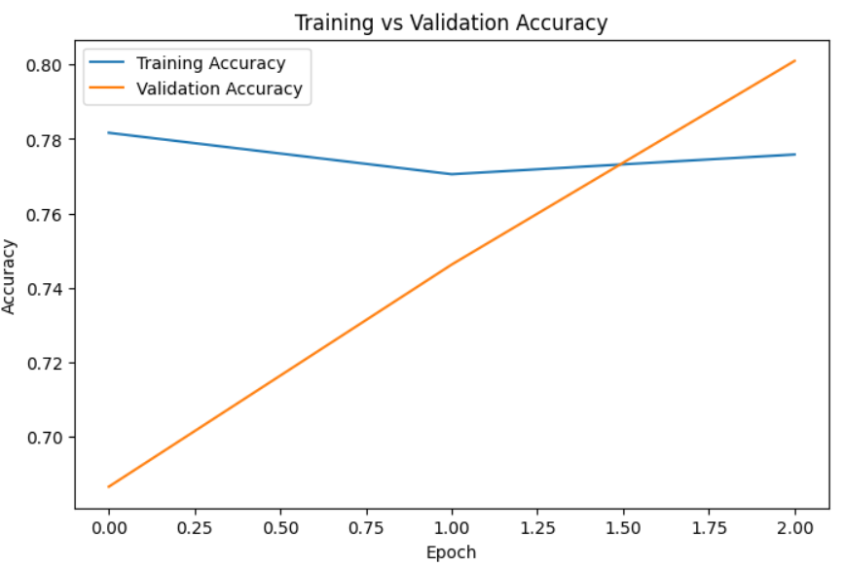
Step 9: Plot Loss
The loss graph helps determine whether the model is learning properly or overfitting.
plt.figure(figsize=(8,5))
plt.plot(history.history["loss"], label="Training Loss")
plt.plot(history.history["val_loss"], label="Validation Loss")
plt.title("Training vs Validation Loss")
plt.xlabel("Epoch")
plt.ylabel("Loss")
plt.legend()
plt.show()

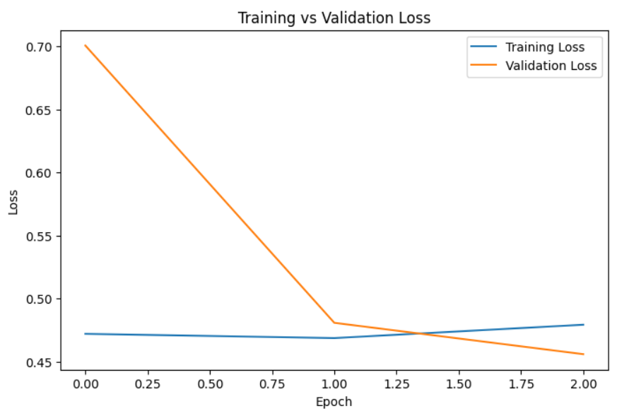
Step 10: Make Predictions
The model predicts the probability of each image belonging to the Fire class. A threshold of 0.5 is used to classify the image as Fire or No Fire.
predictions = model.predict(test_generator)
predicted_classes = (predictions > 0.5).astype(int)
print(predicted_classes[:10])

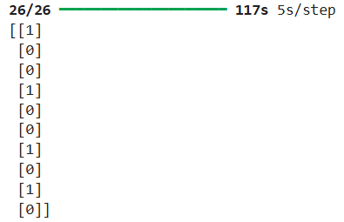
Step 11: Save the Model
The trained CNN model is saved for future use without retraining.
model.save("wildfire_cnn_model.keras")

Step 12: Download the Model (Optional)
This creates a downloadable link for the saved model file in the Kaggle Notebook.
from IPython.display import FileLink
FileLink("wildfire_cnn_model.keras")

Conclusion
This lab implemented an end-to-end forest fire detection pipeline using a Convolutional Neural Network.

